**Main menu:**

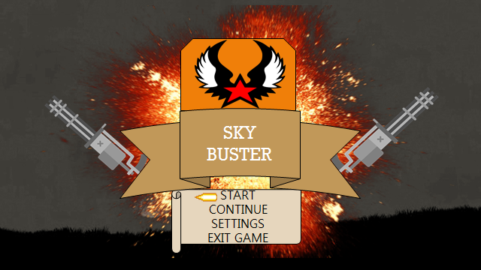

**Logo:**



**Screenshot:**

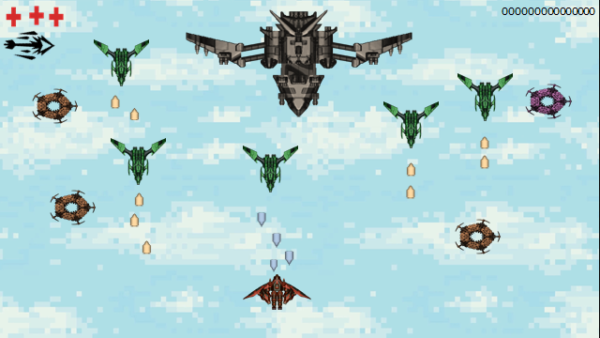

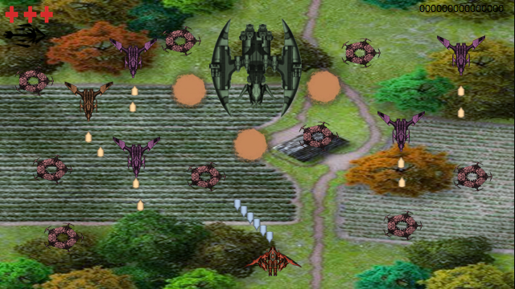

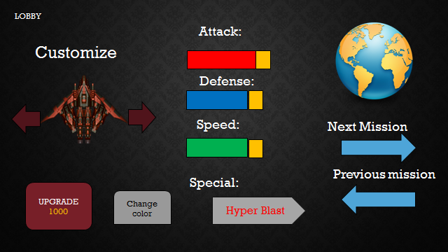

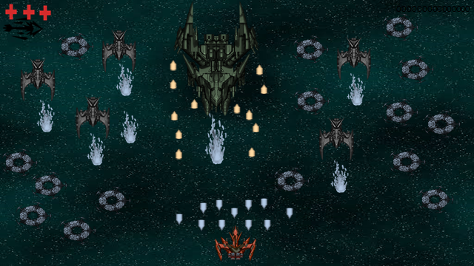

Lindio Ervien Joseph R. Lindio

HCI

**Title:** Sky Buster

**Genre:** Shoot ’em up, Sci-Fi, Action

**Player / Target Market:**  General Audience

**Gameplay:**

You can control your character from any direction and shooting the enemies at them while dodging the multiple enemy fires and projectiles. You have only three (3) lives to survive and if all the lives are gone, you are going from the start of the map and the score will not decrease if you reset the map. You can upgrade your character to improve their stats to become stronger and to increase damage, defense, and speed and customize your character like changing colors or design if you want. Many weapon upgrades has owned special attack to wipeout the enemies or to protect them from enemies attack.

**Story:**

Year 2107, the world of advance technology has been improved year by year. But the evil cyber-terrorist organization known as “Chaos.net” started creating and hacking and copy several of super advances weapons and declared a war by using them to take over the world and create new era for their own. The hidden organization called”Red Star” create their own super weapons called “The Anti-Chaos” in order to stop the evil plans of Chaos.net to take over the world.